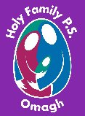
Holy Family Primary School
Newsletter
Friday, 15th March 2024

Pupils of the Week
Class | Name | Reason
Yr.1 NC | Thielen Doughlas | For his excellent life cycle of a butterfly
Yr.1 MP | Jacob McAleer | For creating a beautiful symmetrical butterfly!
Yr.2 EM | James McElroy | For showing the class how to make a paper boat
Yr.2 FMG/NC | Finn O’Neill | For his amazing attitude to his work
Yr.3 SM | Thomas Kearney | For his excellent retelling of the story of St. Patrick
Yr.3 MC | The Whole Class | For their fantastic St. Patrick’s Day assembly – well done superstars!!
Yr.4 CMM | Aoife Woodhead | For her fantastic practical equal sharing
Yr.4 BH | Chloe McDonagh | For settling back into class so well
Yr.5 DMC | Tiernan McLaughlin | For his excellent dancing during the ‘dance day’
Yr.5 DMS | Keelan Mackey | For his enthusiasm and excellent dance skills
Yr.6 SMG | Leo Hyland | For making a great effort to stay focused on his work – well done!
Yr.6 ZMD | Avery Bleakley | For her fantastic creativity & keen interest in nature
Yr.7 CK | Anneka Schouten | For excellent work on ‘the circle’
Yr.7 KMK/AC | Jessica Moore | For an excellent improvement in all aspects of her work

Good Manners Award
Those chosen to receive recognition for the ‘Good Manners’ Award this week are:
Junior Site: Riah Campbell, Lilly-Mae Ward, Dara Taggart, Naomi McDonagh, Rory O’Neill, Hannah Martin, Brody Watson, Ella Taggart & Isa Fegan
Senior Site: Danny Molloy, Cormac McWilliams, Tia Sharp, Fianna Fox, Cora Campbell, Matthew McKenna & Arsenja Trainauskas
Well done everyone, we are so proud of you all.

Healthy Eaters!
Junior Site: Jacob Eccles, Simon Campbell, Joe McCrossan, Khaleesi Harkin, Elena Eccles, Shay Green, Darragh Woodhead & Grace McNulty
Senior Site: Billy Green, Ruairi Donnell, Amelia Czapla, Alan Bedkowski, Casey Sloan & Nathan Kearney
Congratulations everyone – keep up the good work!!

Upcoming Dates to Note
Mon 18th March – St. Patrick’s Day holiday
Sat 23rd March – Easter Bingo Bonanza in St. Joseph’s Hall at 7.30pm. (details overleaf)
Fri 29th March – Fri 5th April – Easter holidays. Pupils finish @ 12noon on Thurs 28th
Mon 6th – Fri 10th May – Mid-term break. School closed for the week
Wed 15th May – Sacrament of Confirmation at 5.00pm in Sacred Heart Church
Sat 18th May – First Holy Communion at 12noon in Sacred Heart Church

Our Super Netballers!!!
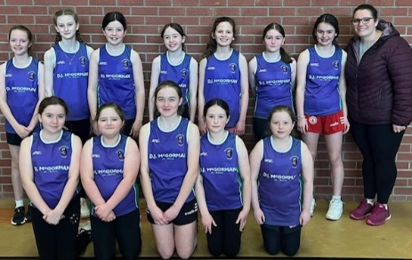
Huge congratulations once again to our super netballers who took part in the second heat of the Netball N.I. League on Tuesday in Omagh Station Centre. The girls had 3 wins and a draw against St. Mary’s Killyclogher A & B teams, St. Conor’s and St. Joseph’s Drumquin!!! It was an amazing display of netballing skills and we sincerely thank our after school coach Siobhan Mullin for all her hard work with the girls. Holy Family now progress to play the winners of the Mid-Ulster section in the upcoming weeks and the winners of that competition will progress to play in the N.I. Primary Schools Finals Day. Congratulations again girls – you are a credit to yourselves, your school and your families.

Easter Bingo Bonanza!!
Our fabulous Parents’ Committee has organised an Easter Bingo Bonanza to take place on Saturday, 23rd March at 7.30pm in St. Joseph’s Hall. This promises to be a night filled with laughter, fantastic prizes and loads of fun, all while supporting our school’s fundraising efforts. There is an impressive £1000 worth of prizes up for grabs so come along and bring your friends and family members to join us for an exciting evening of Bingo!! Single book £10.00, double book £15.00.
N.B. This event is strictly for individuals aged 18 and over.

Save our Strule Eco-Project
The Yr.3 – Yr.7 pupils created beautiful, colourful posters highlighting the important ways in which we can preserve the Strule River Basin, allowing the ecosystem to flourish!! The children really threw themselves into the project and the winners were delighted to receive reusable water bottles provided by Emmett Brogan from Fermanagh & Omagh District Council. A huge thank you to everyone for taking part & congratulations to our worthy winners!!!
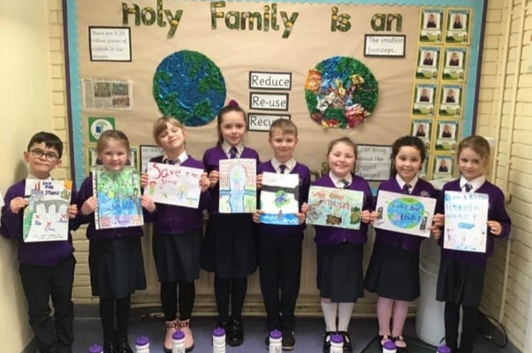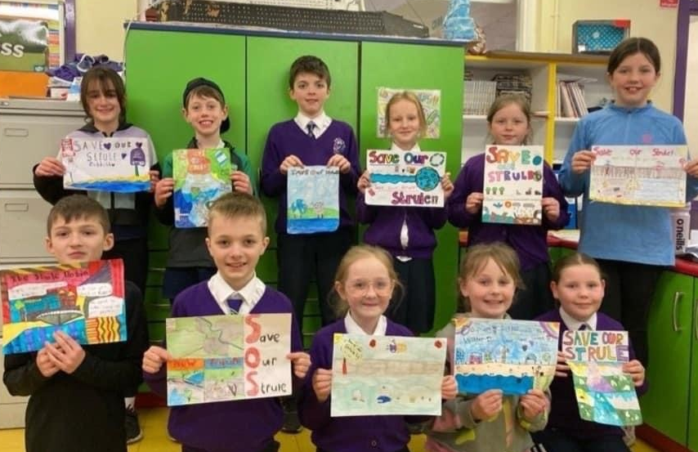

Thought of the week

You’re only here for a short while.
Don’t hurry, don’t worry,
and be sure to smell the flowers along the way

