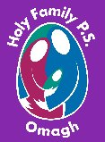
Holy Family Primary School
Newsletter
Friday, 8th March 2024
Pupils of the Week
Class | Name | Reason
Yr.1 NC | Sean Paul McCrory | For being such a good friend
Yr.1 MP | James Nugent | For creating a beautiful butterfly
Yr.2 EM | Niamh O’Neill | For showing super initiative in helping to keep our classroom & cloakroom organised
Yr.2 FMG/NC | Stefania Ursu | For her fantastic description of ‘Cinderella’
Yr.3 SM | Thomas Donaghy | For his super work on adding tens & units
Yr.3 MC | Finbar McMenamin | For the fantastic book he wrote independently – you are an author & an illustrator now!!
Yr.4 CMM | Zalan Csobeth | For his amazing attitude to learning
Yr.4 BH | Conn Gallagher | For writing a lovely recount about his First Confession
Yr.5 DMC | Max Zielinski | For brilliant problem-solving skills
Yr.5 DMS | Paul Slevin | For his excellent mental maths skills
Yr.6 SMG | Fianna Fox | For excellent work in all areas of the curriculum
Yr.6 ZMD | Niamh Woodhead | For her excellent organisational skills
Yr.7 CK | Alan Karol | For excellent discussion work in class
Yr.7 KMK/AC | David Maceasa | For showing great compassion throughout the week

Good Manners Award
Those chosen to receive recognition for the ‘Good Manners’ Award this week are:
Junior Site: Gabriela Pospiech, Ráisa-Maria Tigau, Amelia McKeogh, Michael Starrs, Tommy Donoghue, Sienna Campbell, Zuzanna Wengler, Thomas Kearney, Liliana Lowe & Maisy Mai Molloy.
Senior Site: Anna Tierney, Conan McCann, Kamil Zielinski, Keavy Kincaid, Charlie Ward, Tiernan Donnell, Sophia Maughan & Abbie-Leigh Devlin.
Well done everyone, we are so proud of you all.

Healthy Eaters!
Junior Site: Jacob McAleer, Clarice Donoghue, Niamh O’Neill, Evie McKeogh, Finbar McMenamin, Ada Munton, Maisie Mai Molloy & Alex Pluta
Senior Site: Eoghan McCrory, Ava Nugent, Isabella O’Neill, Fianna Fox, Zuzia Szewczyk & Cora Campbell
Congratulations everyone – keep up the good work!!

Upcoming Dates to Note
Fri 15th March – Special St. Patrick’s Day menu in the canteen (see overleaf)
Mon 18th March – St. Patrick’s Day holiday
Fri 29th March – Fri 5th April – Easter holidays. Pupils finish @ 12noon on Thurs 28th
Mon 6th – Fri 10th May – Mid-term break. School closed for the week
Wed 15th May – Sacrament of Confirmation at 5.00pm in Sacred Heart Church
Sat 18th May – First Holy Communion at 12noon in Sacred Heart Church

A Career in School Catering!!
If you or any of you family are interested in a career in school catering, please read the information leaflet at the end of today’s newsletter.

First Confessions
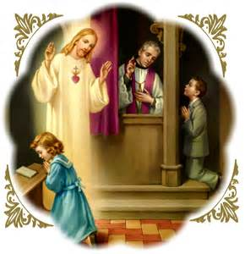
We would like to offer heartiest congratulations to our Yr.4 pupils who made their First Confessions on Tuesday evening. The children were very well prepared for the sacrament and conducted themselves with great dignity and maturity for such a young age. A special word of thanks must go to Fr. Hasson (school chaplain), our fabulous teachers Mrs. McMackin & Mrs Hackett and our fabulous assistants Siobhan, Olive and Pamela for the way they prepared their classes for this special occasion. A huge thank you also to Mr. Paul Pritchard for his beautiful music and singing throughout the ceremony – it really added to the occasion and made it so special for everyone.
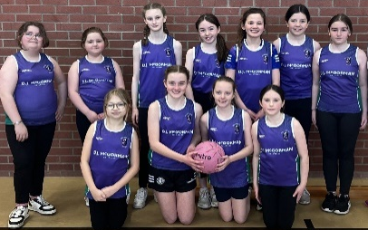
Our Super Netballers!!!
Huge congratulations to our super netballers for winning all their matches in the Netball N.I League last Friday in the Station Centre. The girls were absolutely fantastic showcasing their skills against St. Mary’s Killyclogher A & B teams, St. Conor’s Primary and St. Joseph’s Primary Drumquin. All the hard work at After School Club with Siobhan is most definitely paying off. Many thanks to Amy from Netball N.I. for umpiring the event!

St. Mary’s Students ‘Dance Day’
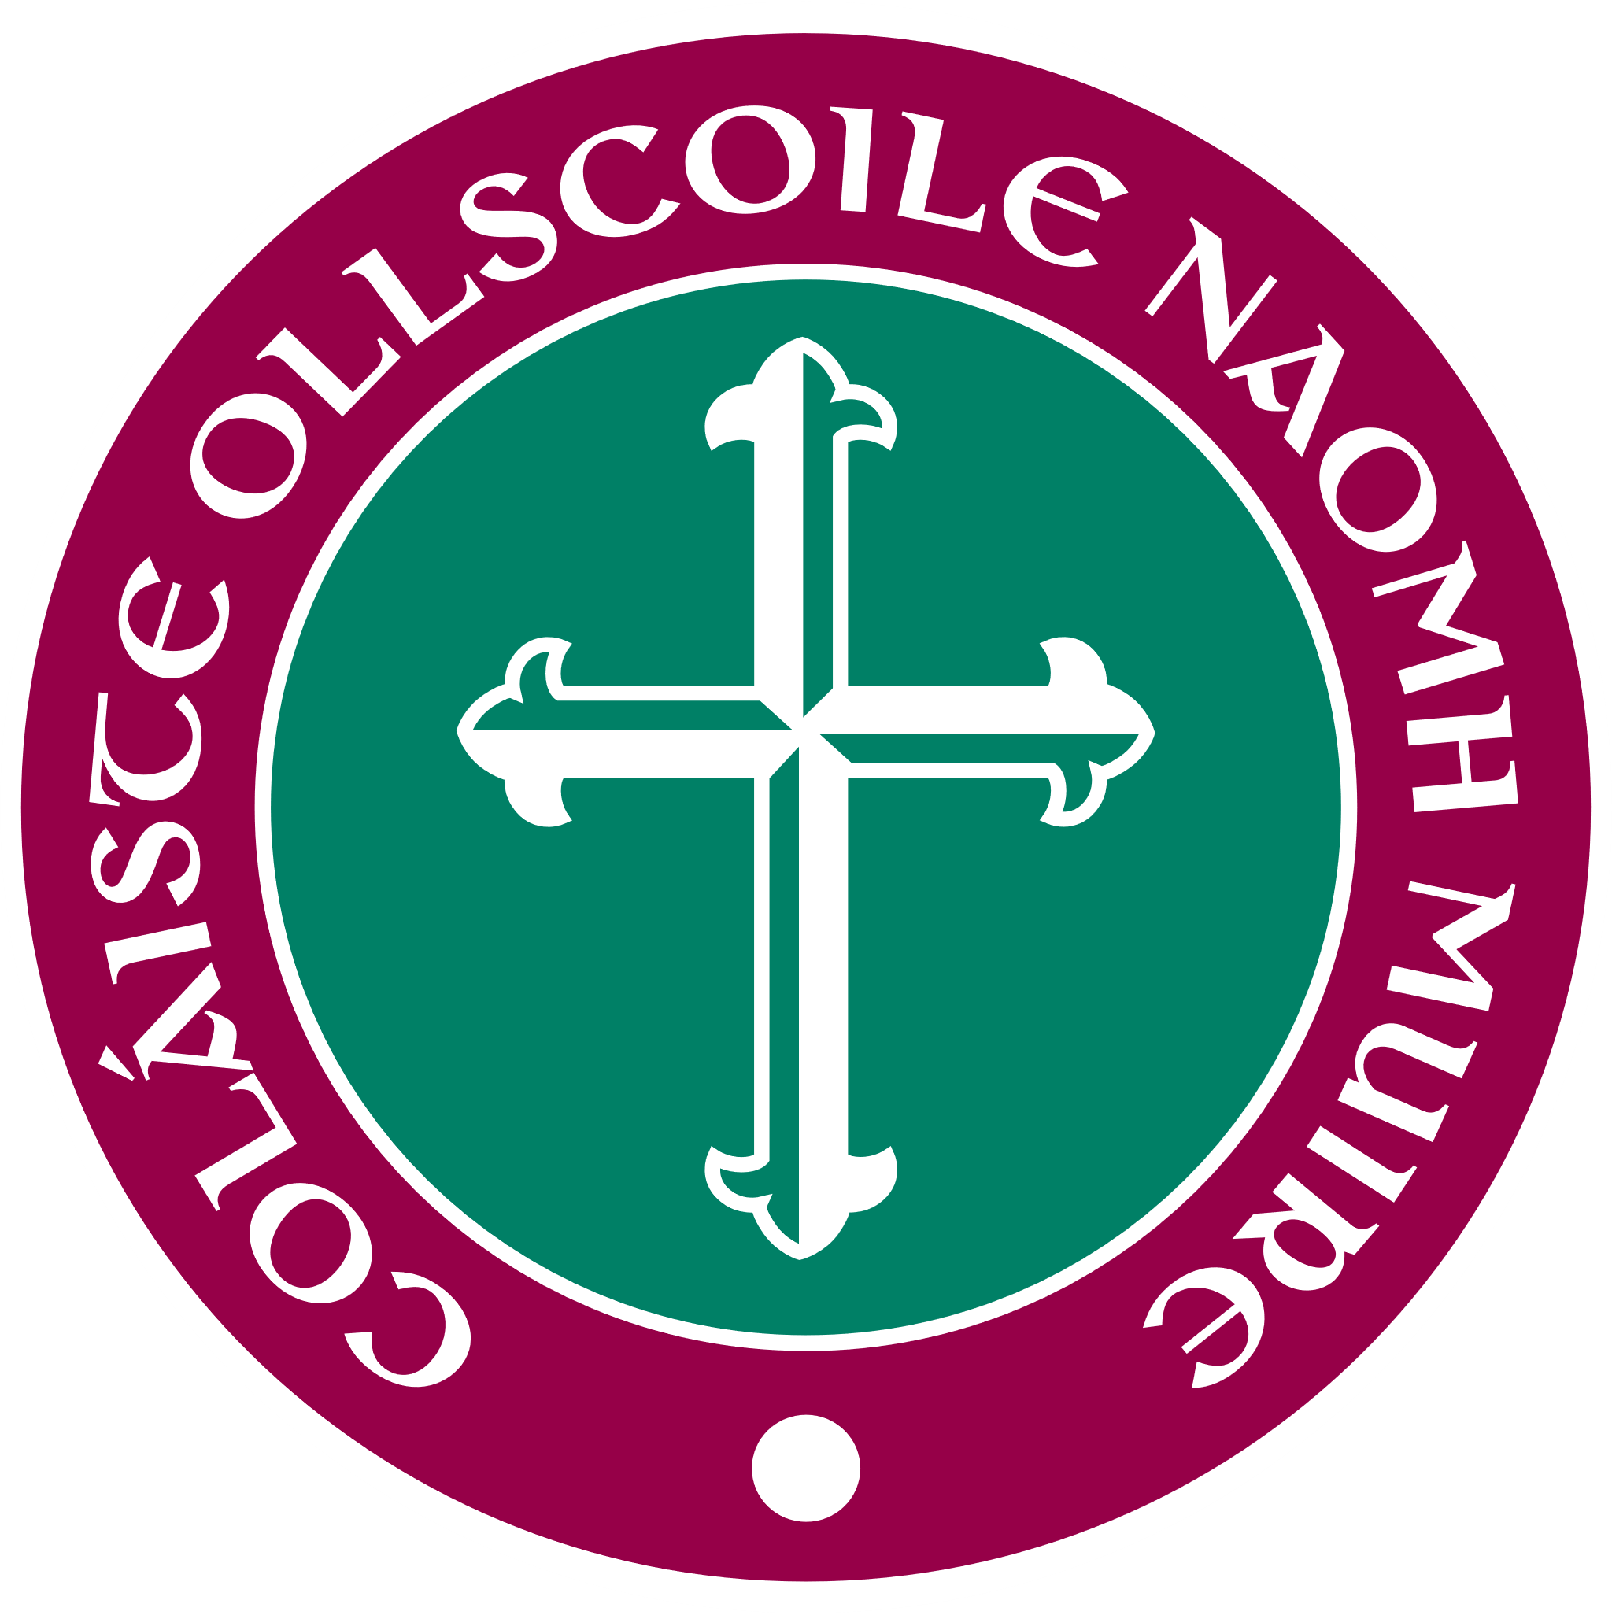
Next Thursday (14th March) students from St. Mary’s University College, Belfast will visit Holy Family for a ‘Day of Dance’ with our pupils!! A number of St. Mary’s students will spend the day on each site and all classes will be involved in a day filled with music and dance. This promises to be a fun-filled occasion for everyone and we ask that all children come to school next Thursday in their P.E. gear, bring plenty of water and an extra healthy snack for break as all the exercise will make them hungry!! A huge thank you to St. Mary’s students for providing this facility to our pupils – we know from previous experience that the pupils will love it!!!
Green Day for St. Patrick’s Day Break
To coincide with the St. Patrick’s Day break we are having a ‘Green Day’ on Friday, 15th March, when pupils can come to school wearing ‘green gear’ instead of their uniform & donate a minimum of £1 for Trocaire! We have had some very creative creations in previous years and have even had St. Patrick himself make an appearance, so we cannot wait to see who decides to visit us this year!!!!!!!!!
N.B. Please don’t buy anything new for this day – anything green such as a t-shirt, hair accessory etc will do fine!!!
The school will be closed on Monday, 18th March for the St. Patrick’s Day holiday. Masses in Drumragh parish will be at the following times:-
Sacred Heart Church, Omagh –Saturday 16th March Vigil Mass at 6.00pm. Sunday 17th March: 9.00am and 12.00noon
St. Mary’s Church, Drumragh – Sunday 17th March @ 10.30am

Thought of the week
Try to be the rainbow in
somebody else’s cloud!!

ST PATRICKS THEME DAY
FRIDAY 15TH MARCH 2024

IRISH STEW/
HOT DOG/VEGGIE DOG
EMERALD PEAS AND CARROTS
MASHED POTATO /CHIPS
LEPRECHAUN SURPRISE DESSERT

