Holy Family P.S.
Policy for

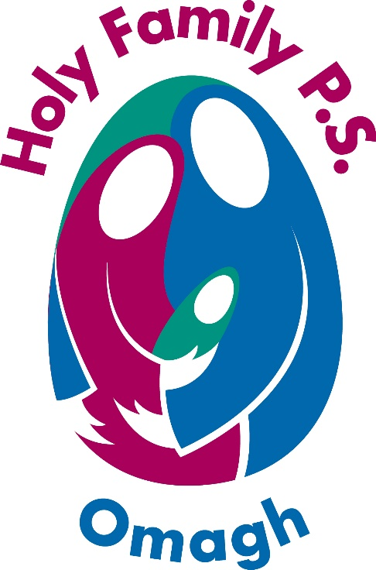

Healthy Eating

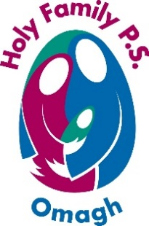
HOLY FAMILY P.S. HEALTHY EATING POLICY GUIDELINES.

Rationale

Children need a healthy diet for normal growth and development. There are growing concerns about what today’s children are eating. Compared to recommended dietary guidelines, many children are consuming too much fat, sugar and salt and too little fibre.

A healthy diet in childhood can help prevent a variety of problems, both in short term (dental decay, amnesia, obesity and constipation), and later in life because the early processes of some adult diseases start in early childhood (coronary heart disease, some cancers, strokes and osteoporosis).

Young people have particular nutrient requirements because they are growing. Their eating habits are likely to influence what they eat in adulthood, so it is important that their eating patterns are optimised at an early age. Food eaten at school which contributes to a healthy diet, provides a good opportunity for young people to put classroom learning into practice.

Schools can help children make healthier choices by ensuring the appropriate food is available and encourage children to make informed choices about what they choose to eat and drink.

At Holy Family P.S. we aim:-
- To establish a clear whole school Healthy Eating Policy with a unified approach, to ensure co-ordination and consistency.
- To ensure pupils have the knowledge, skills and opportunity to make healthy food choices in order to encourage a healthy lifestyle.

Objectives
- To reinforce appropriate messages relating to food, nutrition and dental health e.g. ensuring consistency between the formal curriculum and food provision.
- To provide information to parents/guardians on all aspects of food in school.
- To provide health and well-being for all members of the school community.

Holy Family P.S. aims to do this by:

- Providing access to drinking water in all classrooms throughout the school day.
- Provide awards/ stickers/ certificates assembly recognition for healthy eating.
- Provide a balanced diet through:
- Providing healthy breakfasts in our breakfast club
- Operating a healthy breaks scheme
- Promoting healthy snacks in class
- Promoting healthy choices in school lunches (see appendix 1)
- Supporting the provision of nutritionally balanced school meals
- The provision of milk at breaktimes
- Prevent the consumption of fizzy drinks, sweets and chocolate bars during the school day, except Friday when one treat is permitted.
- Promoting healthy eating through organised themed events e.g. SUSTRANS – smoothie bike, Superhero breakfast etc…
- Reinforcing health messages within the curriculum at each Key Stage.
- Teachers and staff setting an example to pupils through positive attitudes to their own health.
- Current food and health resources made available to staff to use in class

Implementation

The following stakeholders have been thoroughly engaged in developing this policy through discussion. Pupils, parents and staff drew up the food lists in the accompanying appendices and all will be informed of the policy and implementation process
- All staff
- Parents/guardians
- Boards of Governors
- Pupils

Monitoring, Evaluation and Reviewing

As part of the school’s monitoring and evaluation process, we continually keep abreast of new effective initiatives and adapt our practice accordingly. Therefore, this policy will be reviewed by the Principal, Staff and Governors in 2021.

Signed ……………………………………………….. (Chairperson of Holy Family P.S. BOG)
Date ……………………………………………………
Signed …………………………………………………(Principal)
Date …………………………………………………..

Policy Review Date 2020
Appendix 1

Food and drink which should be promoted and consumed in school.

Apples | Flat bread
Oranges | muffin
Pineapple | pancake
Bananas | Pitta pockets
Plums | Crackerbread
Pears | salad
Watermelon | Peppers
Melon | Carrot sticks
Strawberries | Cheese
Blueberries | Humous
Raspberries | Dry cheerios
Grapes | Chicken
Cucumber | Ham
Tomatoes | Turkey
Peaches | Tuna
Mango | Yoghurt
Blackberries | Raisins
Cherries | Yoghurt raisins
Bread | Water
Brown bread | Milk
Bread rolls | Dilute juice (lunchtime only)
Wraps | Lunchables
Crackers | Plain rice cakes
breadsticks | Flavoured water (lunch time only)

Appendix 2

Food and drink which should NOT be promoted and consumed in school.

Chocolate bars | Yoghurt corners with chocolate balls/ biscuits.
Buns | Donuts /pastries
Cakes | Pain au chocolate
Biscuits
Sweets
Lollies
Crisps
Fizzy drinks
Tea cakes
Fruit shoots
Capri sun
Nuts
Nut products
Fruit winders
Chips
Chocolate milk
Flavoured milk
Ribena
Chewing gum
Cupcakes
Energy drinks
Cookies
Custard
Rice pudding

